
DATE: 23 February 2026 – to compare your results in a few months 😊
Your energy is like the battery in your phone; you want to keep it charged so you can use it when you need it.

MY Energy Check
There are ‘five batteries’ that recharge and drive the main dimensions of your energy: Physical, Mental, Emotional, Spiritual, and Social. The 50 statements you just evaluated are key factors (behaviors, facts, habits, and mindsets) showing how you care for each battery: low, medium, or high level of care.
They do not measure your energy level, which fluctuates constantly!
Your Energy Check helps you assess how to be at your best more often across all five dimensions.
A quick definition of your ‘batteries’:
PHYSICAL: your health, stamina, and vitality
MENTAL: your clarity, focus, and intellectual agility
EMOTIONAL: your resilience, creativity, and emotional self-regulation
SPIRITUAL: your values, motivation, and a sense of purpose
SOCIAL: your context: surroundings, relationships, and professional environment

ASSESS THE BIG PICTURE
Let us start by looking at the big picture: your total scores. What are your first impressions? Do you recognize any patterns? What surprises you? Which is your most stable battery, and what impact does it have?

Reminder: the batteries are interdependent, and the 50 factors constantly influence how you think, feel, and act. These five dimensions are only a metaphor for managing your energy more effectively. You and your dynamics are far more complex and unique!

LOW CARE: 10-30 • MEDIUM CARE: 31–39 • HIGH CARE: 40-50
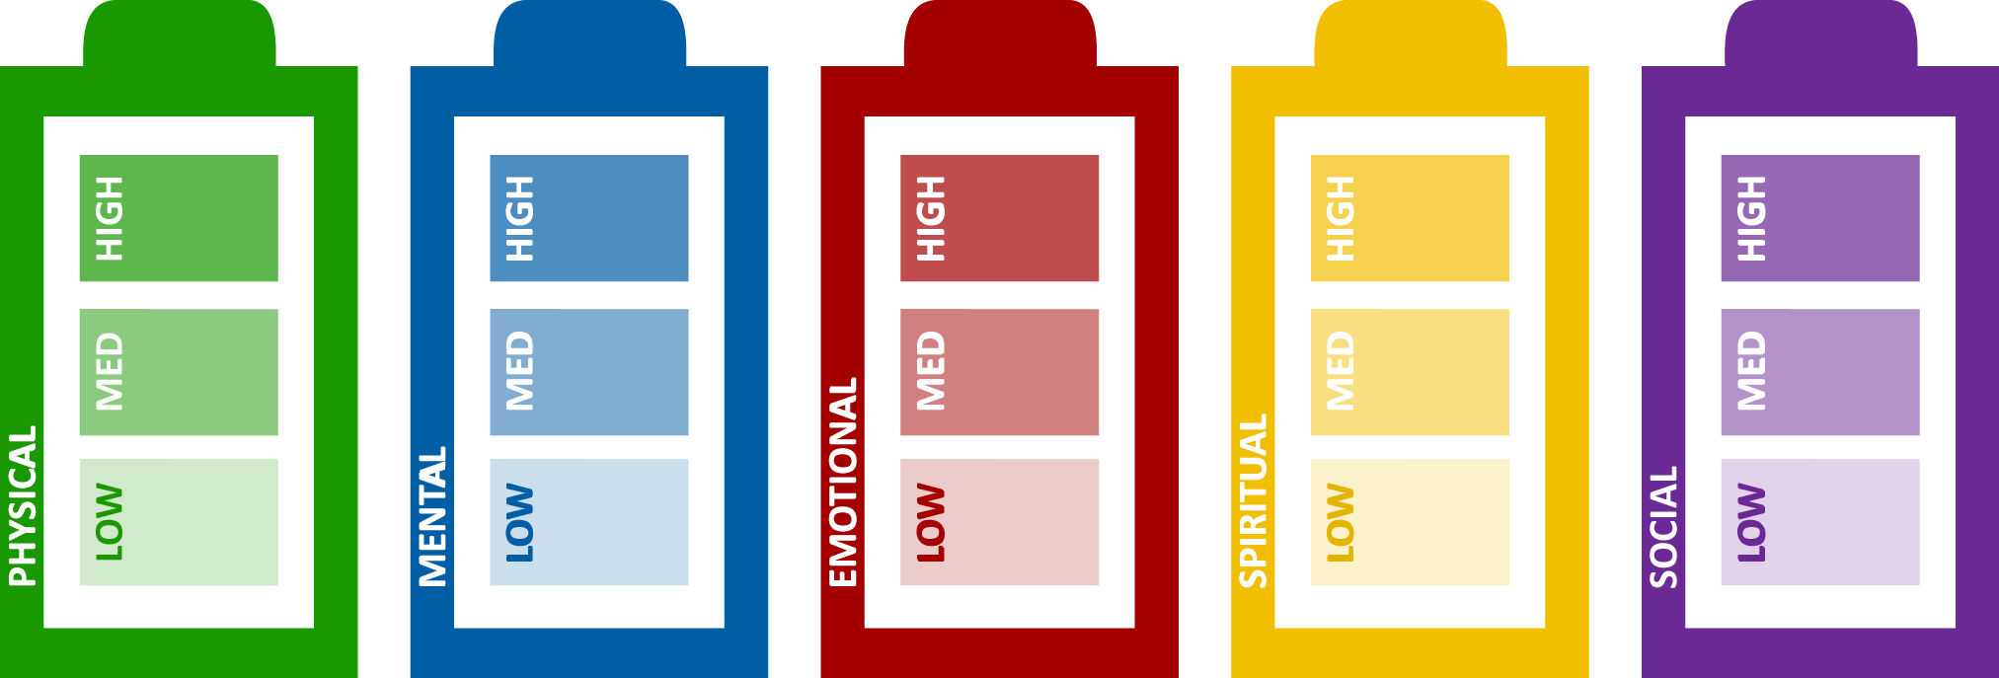
 | ${ph_hi} |  | ${me_hi} |  | ${em_hi} |  | ${sp_hi} |  | ${so_hi}
 | ${ph_mi} |  | ${me_mi} |  | ${em_mi} |  | ${sp_mi} |  | ${so_mi}
 | ${ph_lo} |  | ${me_lo} |  | ${em_lo} |  | ${sp_lo} |  | ${so_lo}

LOW | HIGH
A low score (less than 31, or much lower compared to your other dimensions) is often due to one or more of the following:  - You are neglecting that battery  - You are focusing your energy on the other dimensions and  - Events in your life are affecting it  Most of the time, you can take actions to change it, but sometimes you cannot (e.g., a newborn impacts your sleep, your team does not get along, you work in a crisis zone), and you need to focus on balancing out the impact thanks to the other batteries.  You could leverage this battery more. | A high score (more than 39, or much higher compared to your other dimensions) is often due to one or more of the following:  - You are excellent at taking care of that battery  - You focus most of your energy here, perhaps to the detriment of the other battery  - Events in your life are helping you to care for it  A high score could mean that the battery is your strongest, your ‘secure base,’ which remains stable even during challenging times.  Be mindful not to overutilize it and keep learning how to leverage the other batteries.

QUESTIONS TO GO FURTHER
- How do I feel (not only think!) about my results overall?
- Which aspects of my life are my results helping? Which aspects of my life are hindering?
- Which battery do I pay the most attention to? What is the short-term impact? The long-term one?

- Which battery do I pay the least attention to? What is the short-term impact? The long-term one?
- What could I develop further? Consider also your medium and high scores…not only the low ones!
- Which low scores can I change and which ones do I need to accept - at least for now?

2. IDENTIFY YOUR MOST RELEVANT FACTORS
Now, go back to the 50 factors – these are the behaviors, facts, mindsets, and habits that sustain your energy.
The lower the scores, the more your ‘Drainers’ impact the smooth flow of your well-being. Drainers are like holes in a bucket; it is better to first repair or at least shrink the size of the holes, and only after to pour water into it.
The higher the scores, the stronger your ‘Rechargers’. Rechargers replenish your energy and help you to thrive.
Which are your most important Drainers? And your most important Rechargers?
Some factors are similar across the ‘five batteries’ because they impact multiple dimensions. They are also not ‘equal’ in their impact since a major physical issue will drain you much more than an emotional issue, at least in the short term.

UNDERLINED INDICATORS HAVE HYPERLINKS TO MORE INFORMATION OR PRACTICAL TIPS
Frequency: Almost never Rarely Sometimes Frequently Almost always

 |  |  | PHYSICAL—Total Score: ${ph_sum}
 |  | THE QUANTITY OF YOUR ENERGY
 |  | ${ph_question} |  |  | ${response}
 |  |  |  | MENTAL—Total Score: ${me_sum}
 | THE FOCUS OF YOUR ENERGY
 | ${me_question} |  |  |  | ${response}
 |  |  |  | EMOTIONAL—Total Score: ${em_sum}
 | THE QUALITY OF YOUR ENERGY
 | ${em_question} |  |  |  | ${response}
 |  |  |  | SPIRITUAL—Total Score: ${sp_sum}
 | THE PURPOSE OF YOUR ENERGY
 | ${sp_question} |  |  |  | ${response}
 |  |  |  | SOCIAL—Total Score: ${so_sum}
 | THE CONTEXT of your energy
 | ${so_question} |  |  |  | ${response}

IMPLEMENT NEW MINI-HABITS
For sustainable change, apply the Mini-Habit method. Choose 1 small action that is meaningful for you that you can repeat frequently (4-5 times per week) and do even if you are very busy or tired. For example: go to bed 10 minutes earlier, take a 2-minute break every hour, notice 1 uplifting event.
Choose one. Yes! Start with 1 Mini-Habit that appeals to you. Choose an easy one, then move on to the more challenging actions. Focus on successfully taking each step and moving forward.
Even if you feel a bigger challenge would have a greater impact, sustainable change and lasting new habits come from compounding small steps. I suggest that you redo your Energy Check after a few months. It will help you notice your progress. ‘Practice makes possible long before it makes perfect.’
Click here for a short bibliography about Personal Energy Management and Mini-Habits.

NEXT STEPS TO SUSTAIN YOUR CHANGES
These are more resources to support your new habits:
- Would you like to receive new practical tips? Join my private LinkedIn group and receive a post every
5-6 weeks on your LinkedIn Home page. Manage your Energy - Be your Best & Give your Best.

- Would you like to know more about the battery framework? Read the article in the Harvard Business Review.

- Would you like to summarize your next steps? Download a template.
- The Energy Check is based on the updated edition of my book: Recharge Your Batteries- co-authored with Robert Vilkelis and endorsed by Michael Watkins, the author of The First 90 Days.

- Do you have questions? Reach out on LinkedIn: Francesca Giulia Mereu.

Wishing you good energy and thriving Mini-Habits!

